CITY COUNCIL | 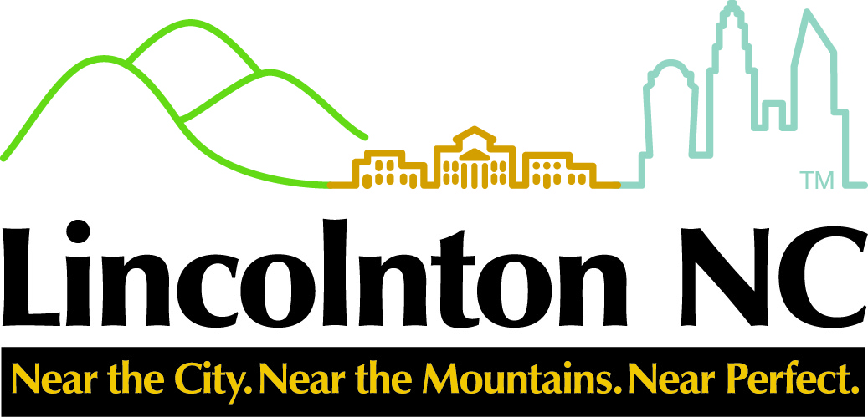 | CITY MANAGER
Ed L. Hatley, Mayor  Martin A. Eaddy, Mayor Pro-Tem  Mary Frances White  Christine Poinsette  Roby Jetton |  | Ritchie Haynes  rhaynes@lincolntonnc.org  CITY CLERK  Daphne Ingram  dingram@lincolntonnc.org  CITY ATTORNEY  Thomas J. Wilson, Jr.

NOTICE OF PUBLIC HEARING

Notice is hereby given, pursuant to N.C. General Statute 158-7.1, that the Lincolnton City Council will hold a public hearing on Thursday, August 4, 2022 at 7:00 p.m. in the Council Chambers located at 114 W. Sycamore Street, Lincolnton. The purpose of the hearing is to receive public comment on a proposed Industrial Incentive Grant agreement between the City of Lincolnton and Active Concepts.

Active Concepts has developed plans for the installation of new manufacturing machinery and equipment and proposes that within two years, make an investment upon their site in building/land and/or machinery and equipment of $4,203,059 and provide at least 12 new jobs paying weekly average wages of $1,150.00 including benefits.

Under the proposed incentive agreement, the City will provide cash grant to Active Concepts of $15,365.38 per year for a five-year period. The City will pay such grants beginning in the tax year after the project’s completion. Grants will be paid to Active Concepts within 30 days after Active Concepts has made its tax payment for the then-current year and has notified Lincoln Economic Development Association of the payment. The amount represents a Level two grant under the City of Lincolnton’s Industrial Development Incentive Grant Policy for New and Existing Industries. The source of funds for considered expenditure described herein is the City’s General Fund.

Further information on this public hearing may be obtained from John Dancoff, Existing Business Manager with Lincoln Economic Development Association, at (704) 732-1511ext. 2. A copy of the proposed Industrial Incentive Grant Agreement is available in the City Clerk’s Office, located on the second floor of City Hall. Citizens wishing to make comment should see the City Clerk prior to the start of the meeting.

Daphne Ingram – City Clerk
City of Lincolnton
704-736-8980 ext 2281

Advertise: July 22, 2022
August 3, 2022

