CITY COUNCIL | 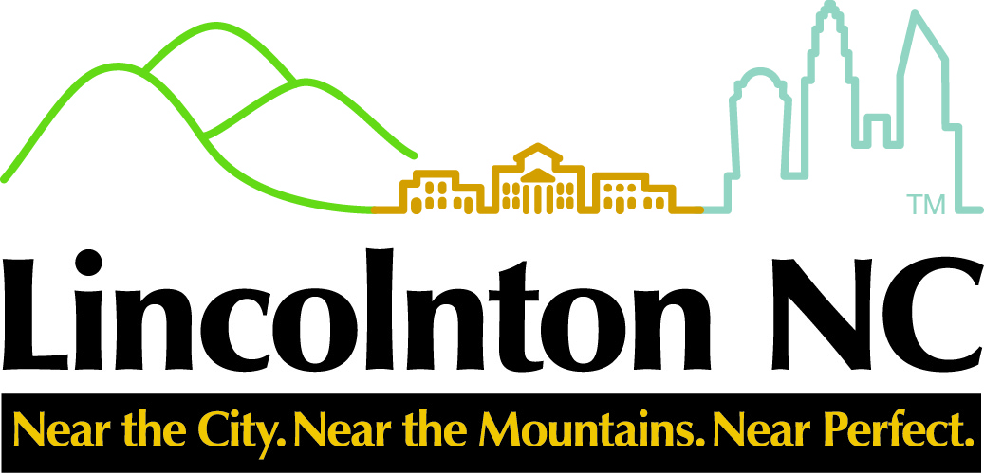 | CITY MANAGER
Ed L. Hatley, Mayor  Martin A. Eaddy, Mayor Pro-Tem  Mary Frances White  Christine Poinsette  Roby D. Jetton |  | Ritchie Haynes  rhaynes@lincolntonnc.org  CITY CLERK  Daphne Ingram  dingram@lincolntonnc.org  CITY ATTORNEY  Thomas J. Wilson, Jr.

NOTICE
CITY OF LINCOLNTON
PUBLIC HEARINGS

Notice is hereby given that a Public Hearing will be held by the Lincolnton City Council on Thursday, August 5, 2021 at 7:00 p.m. in the Council Chambers of City Hall located at 114 West Sycamore Street, Lincolnton, NC concerning the following:

- ZMA-4-2021-Application from Crayton Kale/Alotbetter, LLC requesting the rezoning of 1.36 acres of land from Neighborhood Business (NB) District to the Residential-25 (R-25) District. The subject property is located at 2409 E. NC 150 Highway (Parcel ID 25913).

Parties of interest and citizens shall have the opportunity to be heard and may obtain further information on the scheduled public hearings from the Planning Department on the second floor of City Hall located at 114 West Sycamore Street, Lincolnton 28092 (704) 736-8980

ADVERTISE 2TL: Wednesday July 21, 2021
Wednesday July 28, 2021

