CITY COUNCIL | 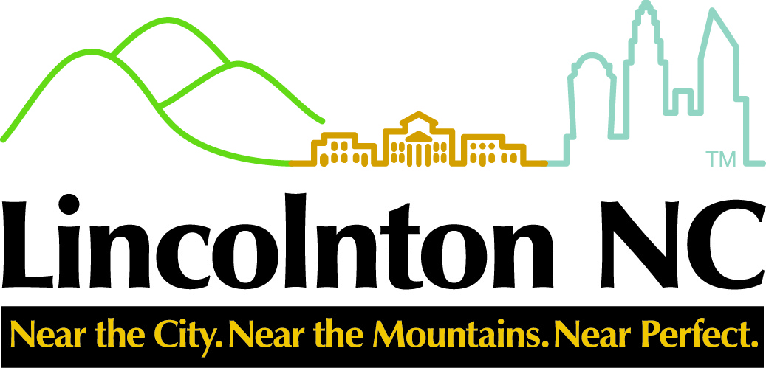 | CITY MANAGER
Ed L. Hatley, Mayor  Martin A. Eaddy, Mayor Pro-Tem  Mary Frances White  Christine Poinsette  Roby Jetton |  | Ritchie Haynes  rhaynes@lincolntonnc.org  CITY CLERK  Daphne Ingram  dingram@lincolntonnc.org  CITY ATTORNEY  Thomas J. Wilson, Jr.

N O T I C E

The Lincolnton Tourism Development Authority will meet on Tuesday, March 4, 2021 at 4:00 p.m. in the Council Chambers at City Hall, 114 West Sycamore Street, Lincolnton, NC 28092.

The purpose of the meeting will be to continue discussions regarding promotional and advertising opportunities for the City of Lincolnton.

Should you have any questions contact Daphne Ingram at (704) 736-8980 or dingram@lincolntonnc.org .

48 hour notification required per NCGS 143-318.12

